**Standardization of Western and Central North Pacific Swordfish (*Xiphias gladius*) Catch Per Unit Effort in the Hawaii Longline Fishery from 1995–2021**

Erin Bohaboy*, Michelle Sculley*

*National Marine Fisheries Service  
1845 Wasp Boulevard  
Honolulu, HI 96818

Email: michelle.sculley@noaa.gov

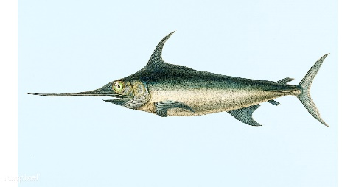

# Abstract

The swordfish (Xiphias gladius) catch per unit effort for the Hawaii-based longline fishery was standardized from the Pacific Islands Regional Observer data set. The fishery was divided into the tuna-targeting deep-set sector and the swordfish-targeting shallow-set sector. Additionally, the shallow-set sector was standardized in two time periods: an early period (1995–2000) and a late period (2005–2021) because the shallow-set fishery was closed from 2001 to 2004, and regulations caused changes in the fleet operations thereafter. Delta binomial-lognormal CPUE standardization models with perspective covariables were evaluated for each fishery and timeseries based on percent deviance explained and models including Four different models were evaluated to standardize the CPUE for each time series: the delta-lognormal model, the negative binomial model, the zero-inflated negative binomial model, and the Poisson model. The delta-lognormal model provided the best model fits and explained the most percent deviance of those evaluated. The selected models explained between 34 and 49% of the deviance in the shallow-set sector and 31% of the deviance in the positive catches for the deep-set sector, but only 9% of the proportion of positive catches in the deep-set sector. The shallow-set standardized annual CPUE values show an increase in catch rates in the early period followed by a peak in 2006 after the closure. CPUE values increased again from 2010 to the present. The CPUE values for the deep-set sector were relatively flat and had high variability.

# Introduction

Broadbill swordfish (*Xiphias gladius*) inhabit the Pacific Ocean between 50° N and 50° S. They are a commercially important highly migratory species caught primarily by the Japanese, Taiwanese, and U.S. longline fisheries (Bigelow *et al.*, 1999). The swordfish stock in the North Pacific has been assessed as a single stock scenario and under a two stock scenario, with one stock in the western central Pacific Ocean (WCNPO) and one stock in the eastern Pacific Ocean (EPO). These stocks were assessed in 2009 and again in 2014 by the Billfish Working Group (BILLWG) of the International Scientific Committee for Tuna and Tuna-like Species in the North Pacific Ocean (ISC) (ISC BILLWG, 2009; ISC BILLWG, 2014). The 2018 assessment of North Pacific swordfish only considered the WCNPO (ISC BILLWG 2019), and subsequent discussions with the Pacific Community and the Inter-American Tropical Tuna Commission (IATTC) redefined the EPO stock as a primarily southern stock. The southwest Pacific stock (SWPO) and the EPO stocks were assessed in 2021 and 2022, respectively (Ducharme-Barth, *et al.*, 2021, Minte-Vera, et al., 2022).

The BILLWG of the International Scientific Committee for Tuna and Tuna-like Species in the North Pacific (ISC) has proposed to attempt a benchmark assessment of North Pacific swordfish Xiphias gladius in 2023. In preparation for the assessment, this working paper describes the standardization of swordfish catch rates from the Hawaii-based longline fleet, which targets swordfish in the shallow-set sector and catches swordfish as bycatch in the deep-set sector. Swordfish are caught as targeted-species in the Hawaiian longline shallow-set fishery sector (< 15 hooks per float) and as bycatch in the tuna-targeting Hawaiian longline deep-set fishery sector (≥ 15 hooks per float). This fleet has been described previously by Ito and Childers (2018) and also in a working paper submitted to the same BILLWG session (Ito 2023) and there have not been additional substantial changes to the fishery since 2018. Historically the Hawaiian longline fishery has targeted tuna; however, in the early 1990s the number of vessels targeting swordfish began increasing and the fleet accounted for 40% of the total US swordfish catch in 2012. Observers were first placed onboard longline vessels in 1994. Interactions with protected sea turtles caused the closure of the shallow-set swordfish fishery from February 2001 to May 2004 (Gilman *et al.,* 2007). During this time many vessels targeting swordfish began targeting tuna. A second closure occurred March–December 2006 when the Hawaii-based shallow-set longline fishery for swordfish reached the annual limit for interactions with loggerhead sea turtles, and additional closures of the fishery have occurred in recent years (NMFS, 2022). Several changes to the reporting regulations have occurred since the onset of required reporting in 1994 (Pacific Islands Region Office, 2017). Observer coverage varied significantly prior to 2000, with observer coverage between 3.3 and 10.4 % for the entire fishery (NMFS, 2022). Starting in 2001, the observer program had a target of 20% observer coverage on deep-set longline vessels and mandatory 100% observer coverage on shallow-set longline vessels.

# Methods

## Data Sources

The US Federal logbook program to monitor the Hawaii-based longline fishing fleet began in November 1990 to manage US domestic fisheries for tuna, swordfish, and other economically important pelagic species. Logbooks are filed by all operators of fishing vessels conducting longline fishing operations on the High Seas and within the U.S. Exclusive Economic Zone in American Samoa, Guam, Hawaii, the Northern Mariana Islands, and U.S. possessions in the western Pacific and offloading in U.S. ports and provide set-by-set information on environmental and operational aspects of fishing operations. The Hawaii-based longline fishery can be divided into two sectors, the tuna-targeting deep-set sector comprises the majority of the fishing fleet and the swordfish-targeting shallow-set sector. Data were extracted from the Oracle database on 2 September 2022. After filtering for incomplete and erroneous entries, there were 424,715 longline sets available for inclusion from 10 June 1995 to 31 December 2021.

Target species are not consistently reported for each longline set in logbook records. Target species (hence fishery sector: deep- vs. shallow-set) were instead inferred by the number of hooks per float (HPF). Deep-sets were defined over the timeseries (1995–2021) as sets with 14 or more HPF. Prior to the close of the shallow-set sector in 2001, shallow-sets targeting swordfish used 10 or fewer HPF. After the reopening of the shallow-set fishery in 2005, fishermen behavior shifted and sets targeting swordfish used 13 or fewer HPF. Based on fishermen behavior prior to 2001, sets with 11, 12, or 13 HPF (*N* = 866 sets, or approximately 0.2% of all records) could not be confidently assigned to either sector and have been removed from these analyses. The location of sets are also generally different between tuna- and swordfish-targeting sets, although location is not included in the identification of deep- vs. shallow-sets. Deep-set trips are typically farther south than the shallow-set trips, which are concentrated around the sub-tropical frontal zone (STFZ) at approximately ## dig N latitude where large swordfish are caught (Sculley et al., 2019).

The environmental variables investigated in the standardization were obtained from publically available data sets. Sea Surface temperatures (SST) from January 1994 to present were based on monthly 0.5° resolution composites from the NOAA GOES-E/W satellite downloaded from Pacific Islands Fisheries Science Center (PIFSC) OceanWatch (2022). The Southern Oscillation Index (SOI), the Pacific Decadal Oscillation Index (PDO), and the el Niño Southern Oscillation Oceanic Niño Index (ONI) were monthly region wide indices (NOAA NCDC, 2022). Mixed layer depth (MLD) were based on 0.33° × 1° monthly means of GODAS data provided by the NOAA/OAR/ESRL PSD, Boulder, Colorado, USA[1]. Latitude and longitude were the calculated Euclidian mid-point between the locations recorded for the beginning of longline set and end of longline haulback. Lunar phase was assigned for each set using the R package ‘lunar’ providing values between 0 and 1 with 0 and 1 as the beginning and end of the moon cycle (new moon), 0.25 as the first quarter, 0.5 as the full moon, and 0.75 as the last quarter. (US Naval Observatory, 2022). Potential seasonal effects on catch rates were accounted for with a day of year value ranging from 1 to 365 (of 366 during leap years). Time of day for each set was the time when the longline deployment began and was measured by hour from 0 to 23. HPF was treated as a categorical variable with values between 1 and 13 for shallow set and increments for deep-set (14–19, 20–25, 26–30, ... , 55–88). The logbook data included over 40 recorded bait types, which were reduced to 8 categories: 1. mackerel, 2. various mixed species (including various combinations of squid, mackerel, saba, sanma, sardine, akule, opelu, and herring), 3. all other species or unknown baits, 4. saba, 5. sanma, 6. sanma/sardine mix, 7. sardine, and 8. squid. Finally, a measure of set effort in total number of hooks was investigated for some standardization some models.

## CPUE Standardization

Catch per unit effort (CPUE) was measured as the count of swordfish caught per 1000 hooks set. Each dataset (shallow-set 1995–2000, shallow-set 2005–2021, and deep-set 1995–2021) was modeled separately as the combination of presence/absence (binomial distributed) and positive catch (lognormal distributed) processes. A presence/absence model was not considered for the shallow-set 2005–2021 standardization because sets catching no swordfish were rare (1.1% of all sets), instead, the CPUE index was standardized based on the lognormal model of positive catches only. This carries the assumption that the probability of catching swordfish in this sector was essentially constant at 1 throughout the timeseries. Each process was modeled with a general additive mixed-effects model in R (package ‘gamm4’) where vessel permit number (a unique identifier that can be used as a proxy for fishing vessel) was included a priori in all models as a random effect to account for possible changes in vessel fishing capability (skill) over time.

Year and random effects of permit were included in all models a priori. Bait type and HPF were considered as categorical variables; SST, SOI, PDO, and MLD were considered as linear terms, latitude and longitude were considered as thin plate regression spline smoothed terms, and moon phase, Yday, and hour were considered as cyclic cubic regression splines. Cyclic cubic regression splines were penalized to ensure model effects for minimum and maximum values of each covariate matched, e.g. 0 and 1 for moon phase, 0 and 366 for Yday, and 0 and 24 for hour. The dimension of the basis (e.g. maximum number of knots) for all smooth terms was 6–8. Models were selected using a forward stepwise approach. All operational and environmental variables were evaluated at each step (total effort was considered only for the binomial presence/absence models). Models containing each candidate covariable were compared to the previous step using a chi2 likelihood ratio test (cites). The model with the lowest AIC value and a significant likelihood ratio test statistic at alpha = 0.05 was retained at each step. Addition of covariates to each model continued only if the gain in percent deviance explained relative to the intercept only (null) model was at least 0.25% relative to the next simplest model.

Residual distributions for each selected presence/absence and positive process model, as well as marginal effects and influence plots for each covariate were examined to ensure model appropriateness.

The annual probability of presence/absence (binomial process) and expected CPUE given positive catch (lognormal process), together with variance estimates, were calculated for all combinations of year x month x categorical variable (either HPF or Bait) included in the model of each timeseries (Walters 2003). Median values for linear and smooth covariables were also used in the predictions. Marginal mean values and variances were calculated by year and, for the shallow-set 1995–2000 and deep-set 1995–2021 timeseries, combined following the approach of Goodman 1960 as described in Campbell (2015) to produce the final standardized CPUE indices.

# Results

## Descriptive Catch Statistics

Swordfish-targeting shallow set longline fishing activity from 1995–2021 has centered 2–3 degrees of latitude north of the western Main Hawaiian Islands (MHI) and has extended farther north along the North Pacific Subtropical Convergence Zone (Figure 1). Prior to the shallow set fishery closure in 2000, most fishing effort was relatively close to the north and south of the MHI, however, since 2005, the spatial extent of fishing effort has been reduced and generally shifted north and east (Figure 2 Figure 3). Nominal CPUE aggregated over the entire timeseries is highest along the North Pacific Subtropical Convergence Zone above the Northwest Hawaiian Islands (Figure 4). Areas of the highest nominal CPUE have been fairly consistent over most of the timeseries, but have shifted farther east in recent years (Figure 5 Figure 6).

Prior to the fishery closure in 2001, shallow set fishing occurred throughout the year (Figure 7A). During the latter timeseries, effort tends to be concentrated within the first months of the year. This seasonal concentration of effort is particularly noticeable during years when the fishery was closed mid-year due to sea turtle interactions (e.g. 2006, 2018, 2019, etc.). During the early timeseries (1995–2000) shallow set longlines were set throughout the day, but mostly between 1600 and 1800 (Figure 7B). The setting of shallow set longlines from 2005–2021 has generally been limited to the evening and early night hours, with effort concentrated from 1800–2000 during most years. Shallow set effort has become increasingly focused around full moon in recent years (Figure 7C). The spatial shift of the fishery to the north and east over the years, as well as increased variability of the set location in recent years are apparent from the relative frequency of sets per year by latitude (Figure 7D) and longitude (Figure 8A). Finally, there was a pronounced shift in fishermen behavior in 2010–2011 (Figure 8B). In years earlier, shallow sets most commonly had 4 HPF, but since 2012 most sets used 5 HPF. The identity of fishery participants, as indicated by the number of sets per vessel permit by year, has also shifted over time as new participants entered the fishery and others left (Figure 9).

Repeat those descriptions for the deep set sector. ( Figure 10 to Figure 18) Effort is concentrated close to MHI consistently over the timeseries. CPUE is very small throughout the range of the deep set fishery, with the exception of a few hotspots in space (convergence zone) and time (especially 1996 and to a lesser extent 2011 and 2012). If I had to remake figs 11 and 12 I would group CPUE 5 and above into a plus group and have a better scale range for the < 5. Time of day is between 0600 and noon, and has shifted later over time. Squid only has not been used as a bait type by the deep set fishery since 2002. HPF has decreased from mode of 31-35 before 2004 to 21-25 after 2007. Participation: more vessels, each fishing more per year with some attrition apparent in 2020 and 2021.

## CPUE Standardization

Time of day, time of year, latitude, and HPF were selected for both the presence/absence and positive catch GAMMs for the 1995-2000 shallow-set fishery (Table 1). In addition, the positive process model included moon phase and longitude. Both models explained approximately 48–49% of deviance compared to the null (intercept only) model. The 2005-2021 shallow-set fishery was modeled using only the positive process GAMM and included moon

# Discussion

yday and lat were selected in all models.

# Literature Cited

Bigelow, K. A., C. H. Boggs and He, X. I. 1999. Environmental effects on swordfish and blue shark catch rates in the US North Pacific longline fishery. Fisheries Oceanography 8(3): 178-198.

Ducharme-Barth, N., C. Catillo-Jordan, J. Hampton, P. Williams, G. Pilling, and Hamer, P. 2021. Stock assessment of southwest Pacific swordfish. WCPFC-SC17-2021/SA-WP-04. 151 pp.

Gilman, E., D. Kobayashi, T. Swenarton, N. Brothers, P. Dalzell and Kinan-Kelly, I. 2007. Reducing sea turtle interactions in the Hawaii-based longline swordfish fishery. Biological Conservation 139(1–2): 19-28.

ISC BILLWG. 2009. Report of the billfish working group workshop (Annex 7). International Scientific Committee for Tuna and Tuna-like Species in the North Pacific Ocean 19-26 May 2009. Busan, Korea.

ISC BILLWG. 2014. North Pacific Swordfish (*Xiphiaus gladius*) Stock Assessment in 2014. International Scientific Committee for Tuna and Tuna-like Species in the North Pacific Ocean 16-22 July 2014. Taipei, Chinese-Taipei.

ISC BILLWG. 2019. Stock Assessment for Swordfish (*Xiphias gladius*) in the Wetern and Central North Pacific Ocean through 2016. International Scientific Committee for Tuna and Tuna-like Species in the North Pacific Ocean 11-16 July 2018. Yeosu, Republic of Korea.

Ito, R.Y. and Childers, J. 2018. US Swordfish Fisheries in the North Pacific Ocean. ISC/18/BILLWG-01/01.

Ito, R.Y. 2022. US Swordfish Fisheries in the North Pacific Ocean.

Minte-Vera, C.V., M.N. Maunder, H. Xu, C.E. Lennert-Cody, J.L. Valero, and Aires-da-silva, A. 2022. South EPO swordfish benchmark assessment: progress report. Inter-American Tropical Tuna Commission Scientific Advisory Committee Meeting. 16-20 May, 2022. La Jolla, California, USA. SAC-13-09. 3 pp.

NMFS. 2022. Hawaii longline fishery logbook statistics -non-confidential summary tables. Available online at <http://www.pifsc.noaa.gov/fmb/reports.php>, accessed 1 October 2022. National Marine Fisheries Service, Pacific Islands Fisheries Science Center, Honolulu.

NOAA NCDC 2022. Spatially and temporally large-scale anomalies that influence the variability of the atmospheric circulation. Online Database <https://www.ncdc.noaa.gov/teleconnections/> Accessed 05 September 2022.

Pacific Islands Fisheries Science Center (PIFSC) OceanWatch. (2022) Central Pacific Node. <http://pifsc-oceanwatch.irc.noaa.gov/> Accessed: 05 September 2022.

Pacific Islands Region Office (PIRO). 2017. Hawaii Longline Observer Program Observer Field Manual. Version LM.17.02. National Oceanic and Atmospheric Administration, Pacific Islands Region, Honolulu, Hawai‛i.

Sculley, M. (2019). Standardization of the Striped Marlin (Kajikia audax) Catch per Unit Effort Data Caught by the Hawaii-based Longline Fishery from 1994-2017 Using Generalized Linear Models. ISC/19/BILLWG-01/06.

U.S. Naval Observatory. 2017. Fraction of the Moon Illuminated at Midnight Hawaii-Aleutian Standard Time. <http://aa.usno.navy.mil/data/docs/MoonFraction.php> Accessed 10 October 2017.

.

# **Tables**

Table . Selected models used in the CPUE standardization. All models included year and random effects of permit. Additive (smooth) terms are noted by s(). Model covariates include hour (Hour), day of year (Yday), latitude (Lat), longitude (Lon), hooks per float (HPF), moon phase (Moon), sea surface temperature (SST), and bait type (Bait).

|  |  |  |  |
| --- | --- | --- | --- |
| **Form / Process** | **Model Covariates** | **% Deviance Explained** | **Comments** |
| Shallow Set, 1995–2000 (*N* = 24,233; 14.7% zeros) | | | |
| GAMM presence / absence | s(Hour) + s(Yday) + s(Lat) + HPF | 48.4 | Lon and Moon were eliminated from consideration after Lat was selected due to convergence failure. |
| GAMM positive process | s(Lat) + s(Yday) + s(Moon) + s(Lon) + s(Hour) + HPF | 48.9 |  |
| Shallow Set, 2005–2021 (*N* = 18,723; 1.1% zeros) | | | |
| GAMM positive process | s(Moon) + s(Yday) + SST + s(Lon) + s(Lat) | 34.4 |  |
| Deep Set, 1995–2021 (*N* = 380,915; 84.2% zeros) | | | |
| GAMM presence / absence | s(Yday) + SST + s(Lat) | 8.8 | Model selection performed using a subset of data (5%) |
| GAMM positive process | s(Hour) + s(Yday) + Bait + s(Lat) + SST + HPF | 30.9 |  |

Table . Annual standardized CPUE (number per 1000 hooks) and CVs.

|  |  |  |  |  |
| --- | --- | --- | --- | --- |
| **Year** | **Shallow Set** | | **Deep Set** | |
| **CPUE** | **CV** | **CPUE** | **CV** |
| 1995 | 6.36 | 0.09 | 0.30 | 0.12 |
| 1996 | 6.85 | 0.09 | 0.19 | 0.11 |
| 1997 | 7.80 | 0.1 | 0.12 | 0.12 |
| 1998 | 7.85 | 0.1 | 0.17 | 0.11 |
| 1999 | 7.69 | 0.08 | 0.15 | 0.11 |
| 2000 | 8.07 | 0.08 | 0.13 | 0.11 |
| 2001 |  |  | 0.14 | 0.11 |
| 2002 |  |  | 0.18 | 0.11 |
| 2003 |  |  | 0.16 | 0.11 |
| 2004 |  |  | 0.21 | 0.10 |
| 2005 | 15.25 | 0.09 | 0.15 | 0.11 |
| 2006 | 16.87 | 0.08 | 0.16 | 0.11 |
| 2007 | 14.16 | 0.09 | 0.15 | 0.11 |
| 2008 | 13.20 | 0.09 | 0.14 | 0.11 |
| 2009 | 10.69 | 0.09 | 0.15 | 0.11 |
| 2010 | 9.74 | 0.09 | 0.13 | 0.11 |
| 2011 | 10.69 | 0.09 | 0.11 | 0.11 |
| 2012 | 9.28 | 0.09 | 0.13 | 0.11 |
| 2013 | 9.31 | 0.09 | 0.13 | 0.11 |
| 2014 | 9.51 | 0.09 | 0.17 | 0.10 |
| 2015 | 10.61 | 0.09 | 0.18 | 0.10 |
| 2016 | 12.29 | 0.09 | 0.15 | 0.10 |
| 2017 | 12.19 | 0.09 | 0.16 | 0.10 |
| 2018 | 10.22 | 0.09 | 0.16 | 0.10 |
| 2019 | 8.86 | 0.09 | 0.13 | 0.11 |
| 2020 | 9.14 | 0.09 | 0.10 | 0.11 |
| 2021 | 7.20 | 0.09 | 0.11 | 0.11 |

# Figures

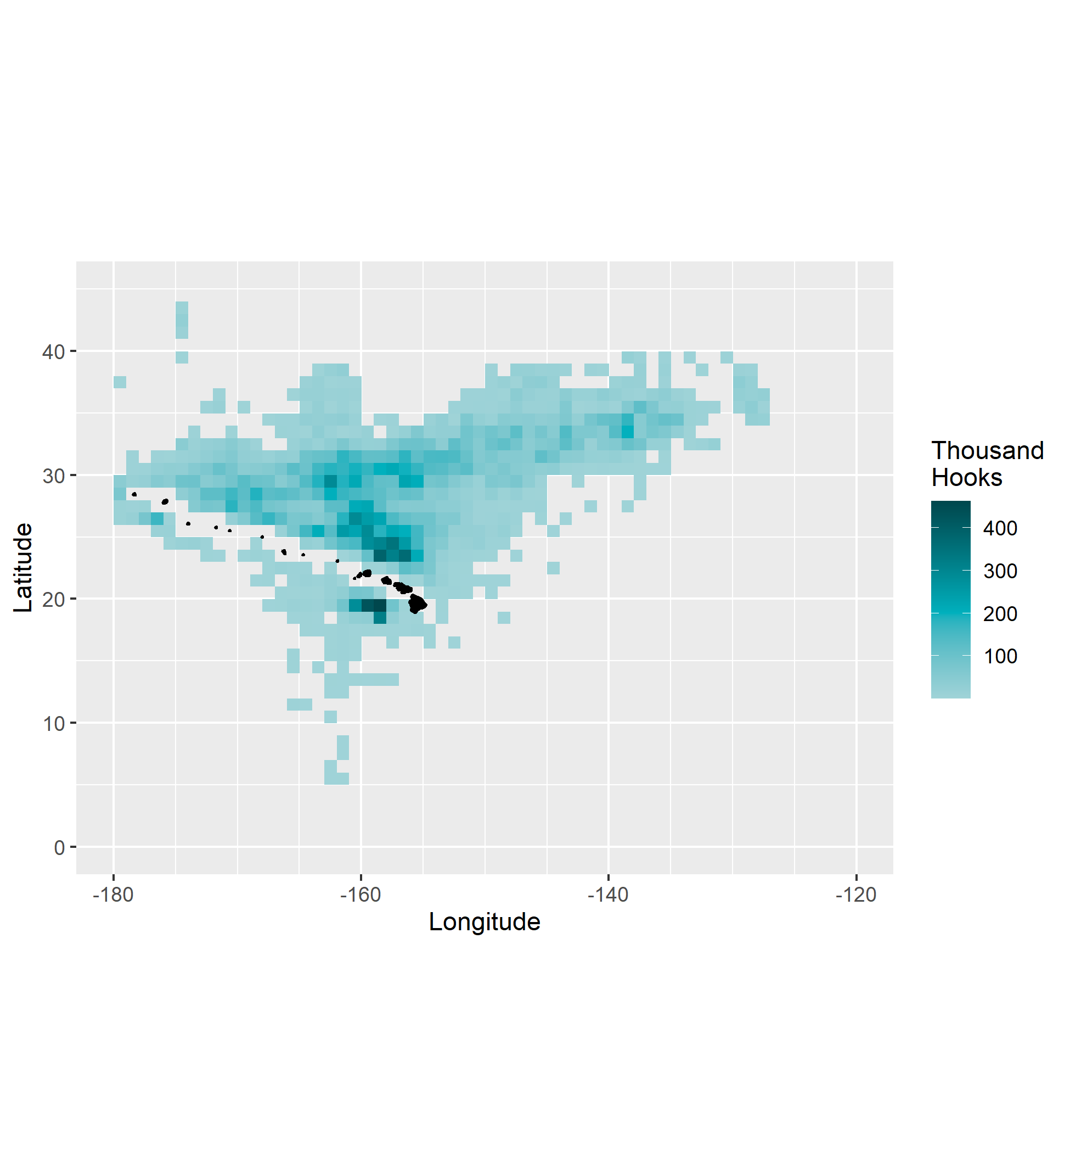

Figure . Total shallow set fishing effort, in thousand hooks, aggregated from 1995–2021. Gridcells with fewer than 3 vessels have been excluded from the plot for confidentiality.

# 

Figure . Shallow set effort by year, in thousand hooks, 1995–2010. Gridcells with fewer than 3 vessels have been excluded from the plot for confidentiality.

# 

Figure . Shallow set effort by year, in thousand hooks, 2011–2021. Gridcells with fewer than 3 vessels have been excluded from the plot for confidentiality.

# 

Figure . Total shallow set nominal CPUE, in number per 1000 hooks, 1995–2021.

# 

Figure . Shallow set nominal CPUE by year, in number per 1000 hooks, 1995–2010.

# 

Figure . Shallow set nominal CPUE by year, in number per 1000 hooks, 2011–2021.

|  |  |
| --- | --- |
| A  B |  |
| C  D |  |

Figure . Relative frequency plots of shallow sets per year by (A) time of year, (B) time of day, (C) moon phase, and (D) latitude. The y-axes are scaled so shaded area is equivalent for each year within each covariable.

|  |  |
| --- | --- |
|  |  |

Figure . Relative frequency plots of shallow sets per year by (A) longitude and (B) hooks per float (HPF).

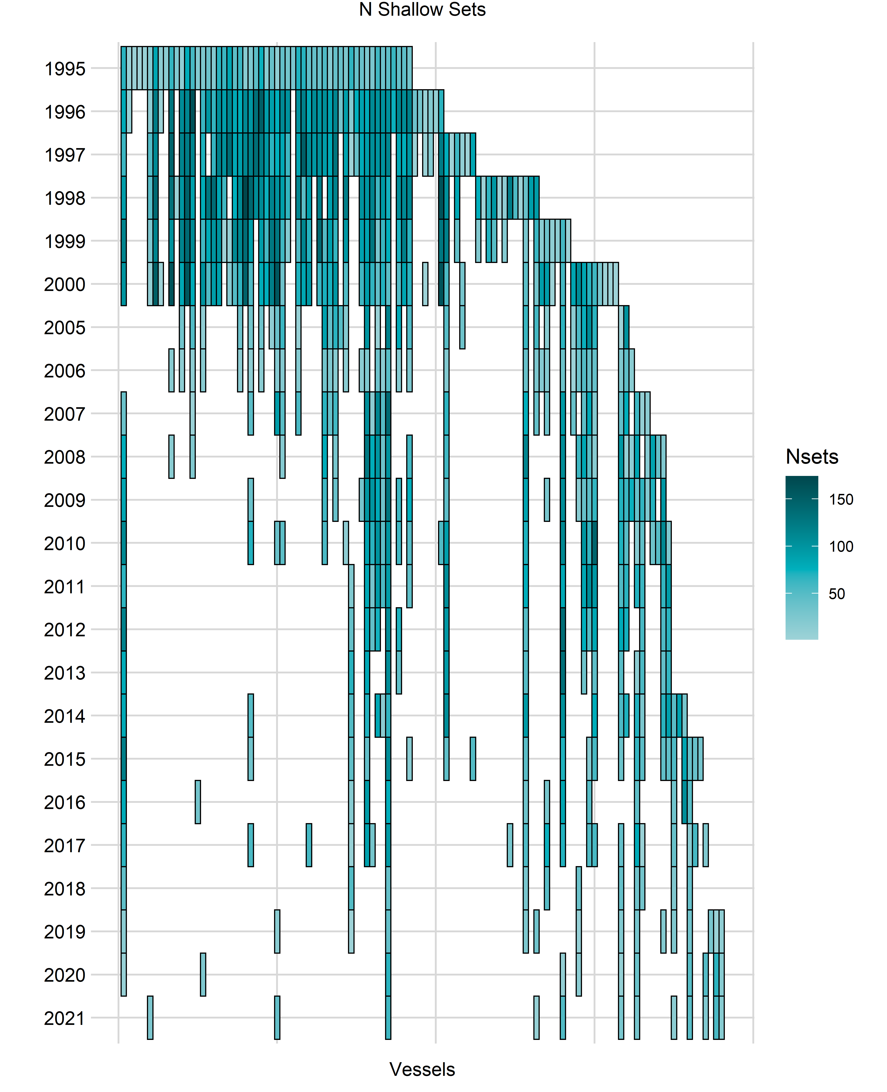

Figure . Shallow set effort per year, in number of sets, by fishing vessel.

# 

Figure . Total deep set effort, in thousand hooks, 1995–2021.

# 

Figure . Deep set effort by year, in thousand hooks, 1995–2009.

# 

Figure . Deep set effort by year, in thousand hooks, 2010–2021.

# 

Figure . Total deep set nominal CPUE, in number per 1000 hooks, 1995–2021.

# 

Figure . Deep set nominal CPUE by year, in number per 1000 hooks, 1995–2009.

# 

Figure . Deep set nominal CPUE by year, in number per 1000 hooks, 2010–2021

|  |  |
| --- | --- |
|  |  |
|  |  |

Figure . Relative frequency plots of deep sets per year by (A) time of year, (B) time of day, (c) latitude, and (D) sea surface temperature (SST).

|  |  |
| --- | --- |
|  |  |

Figure . Relative frequency plots of deep sets per year by (A) bait type and (B) hooks per float (HPF).

# 

Figure . Deep set effort per year, in number of sets, by fishing vessel.

# 

Figure . Shallow set annual standardized CPUE (triangles) with 95% confidence intervals (shaded) for the 1995–2000 and 2005–2021 timeseries. Open symbols are nominal CPUE.

# 

Figure . Deep set annual standardized CPUE (triangles) with 95% confidence intervals (shaded) for 1995–2021. Open symbols are nominal CPUE.

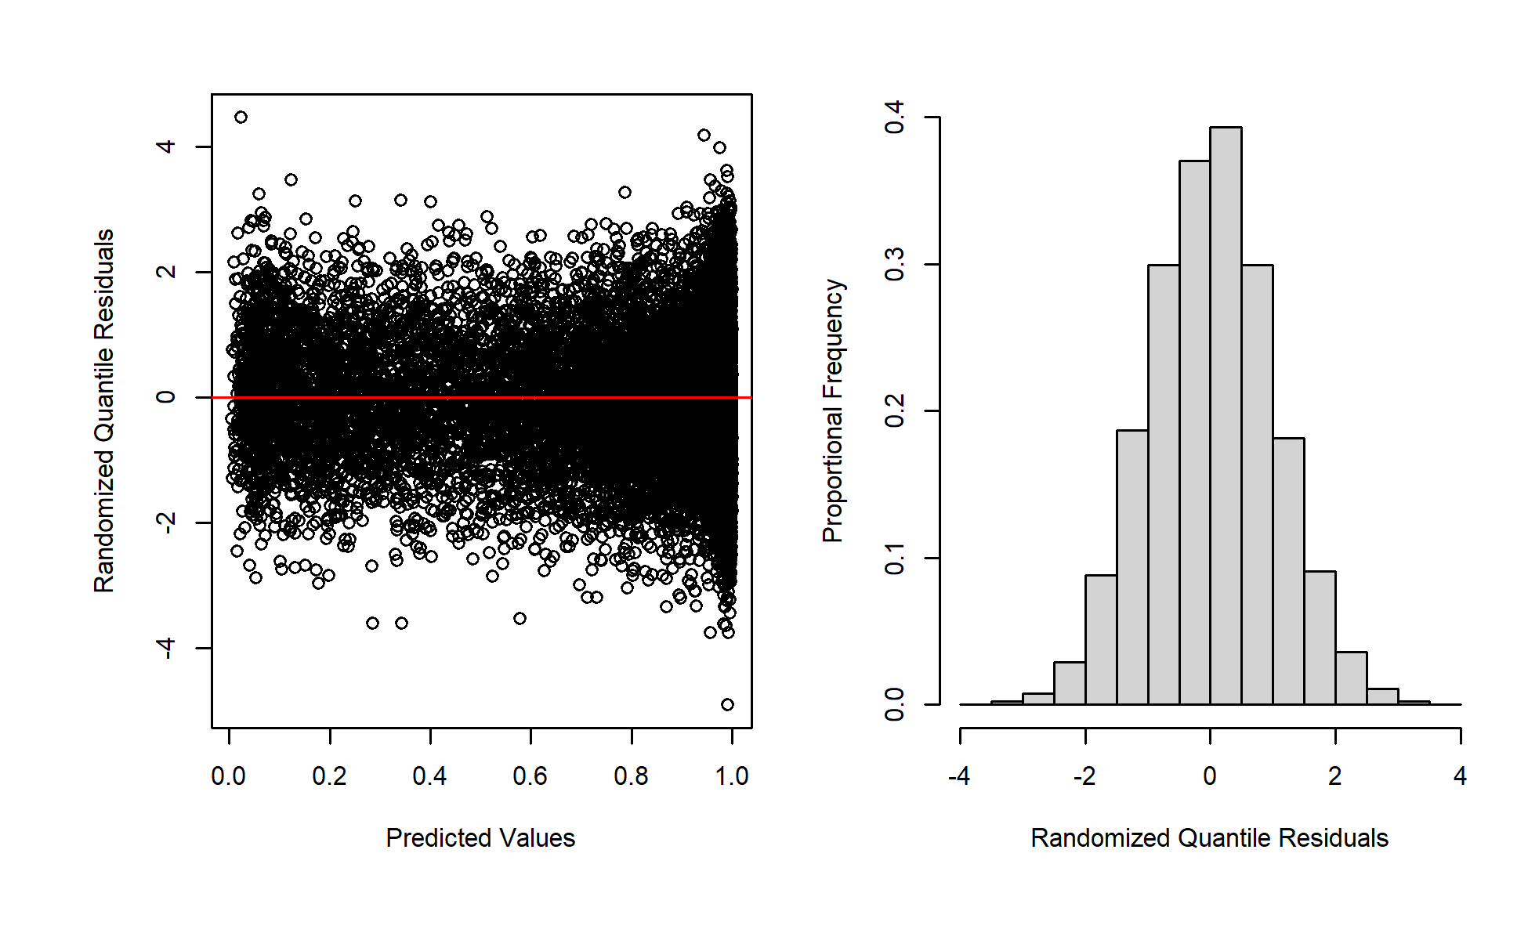

Figure . Diagnostic plots for shallow set 1995-2000.

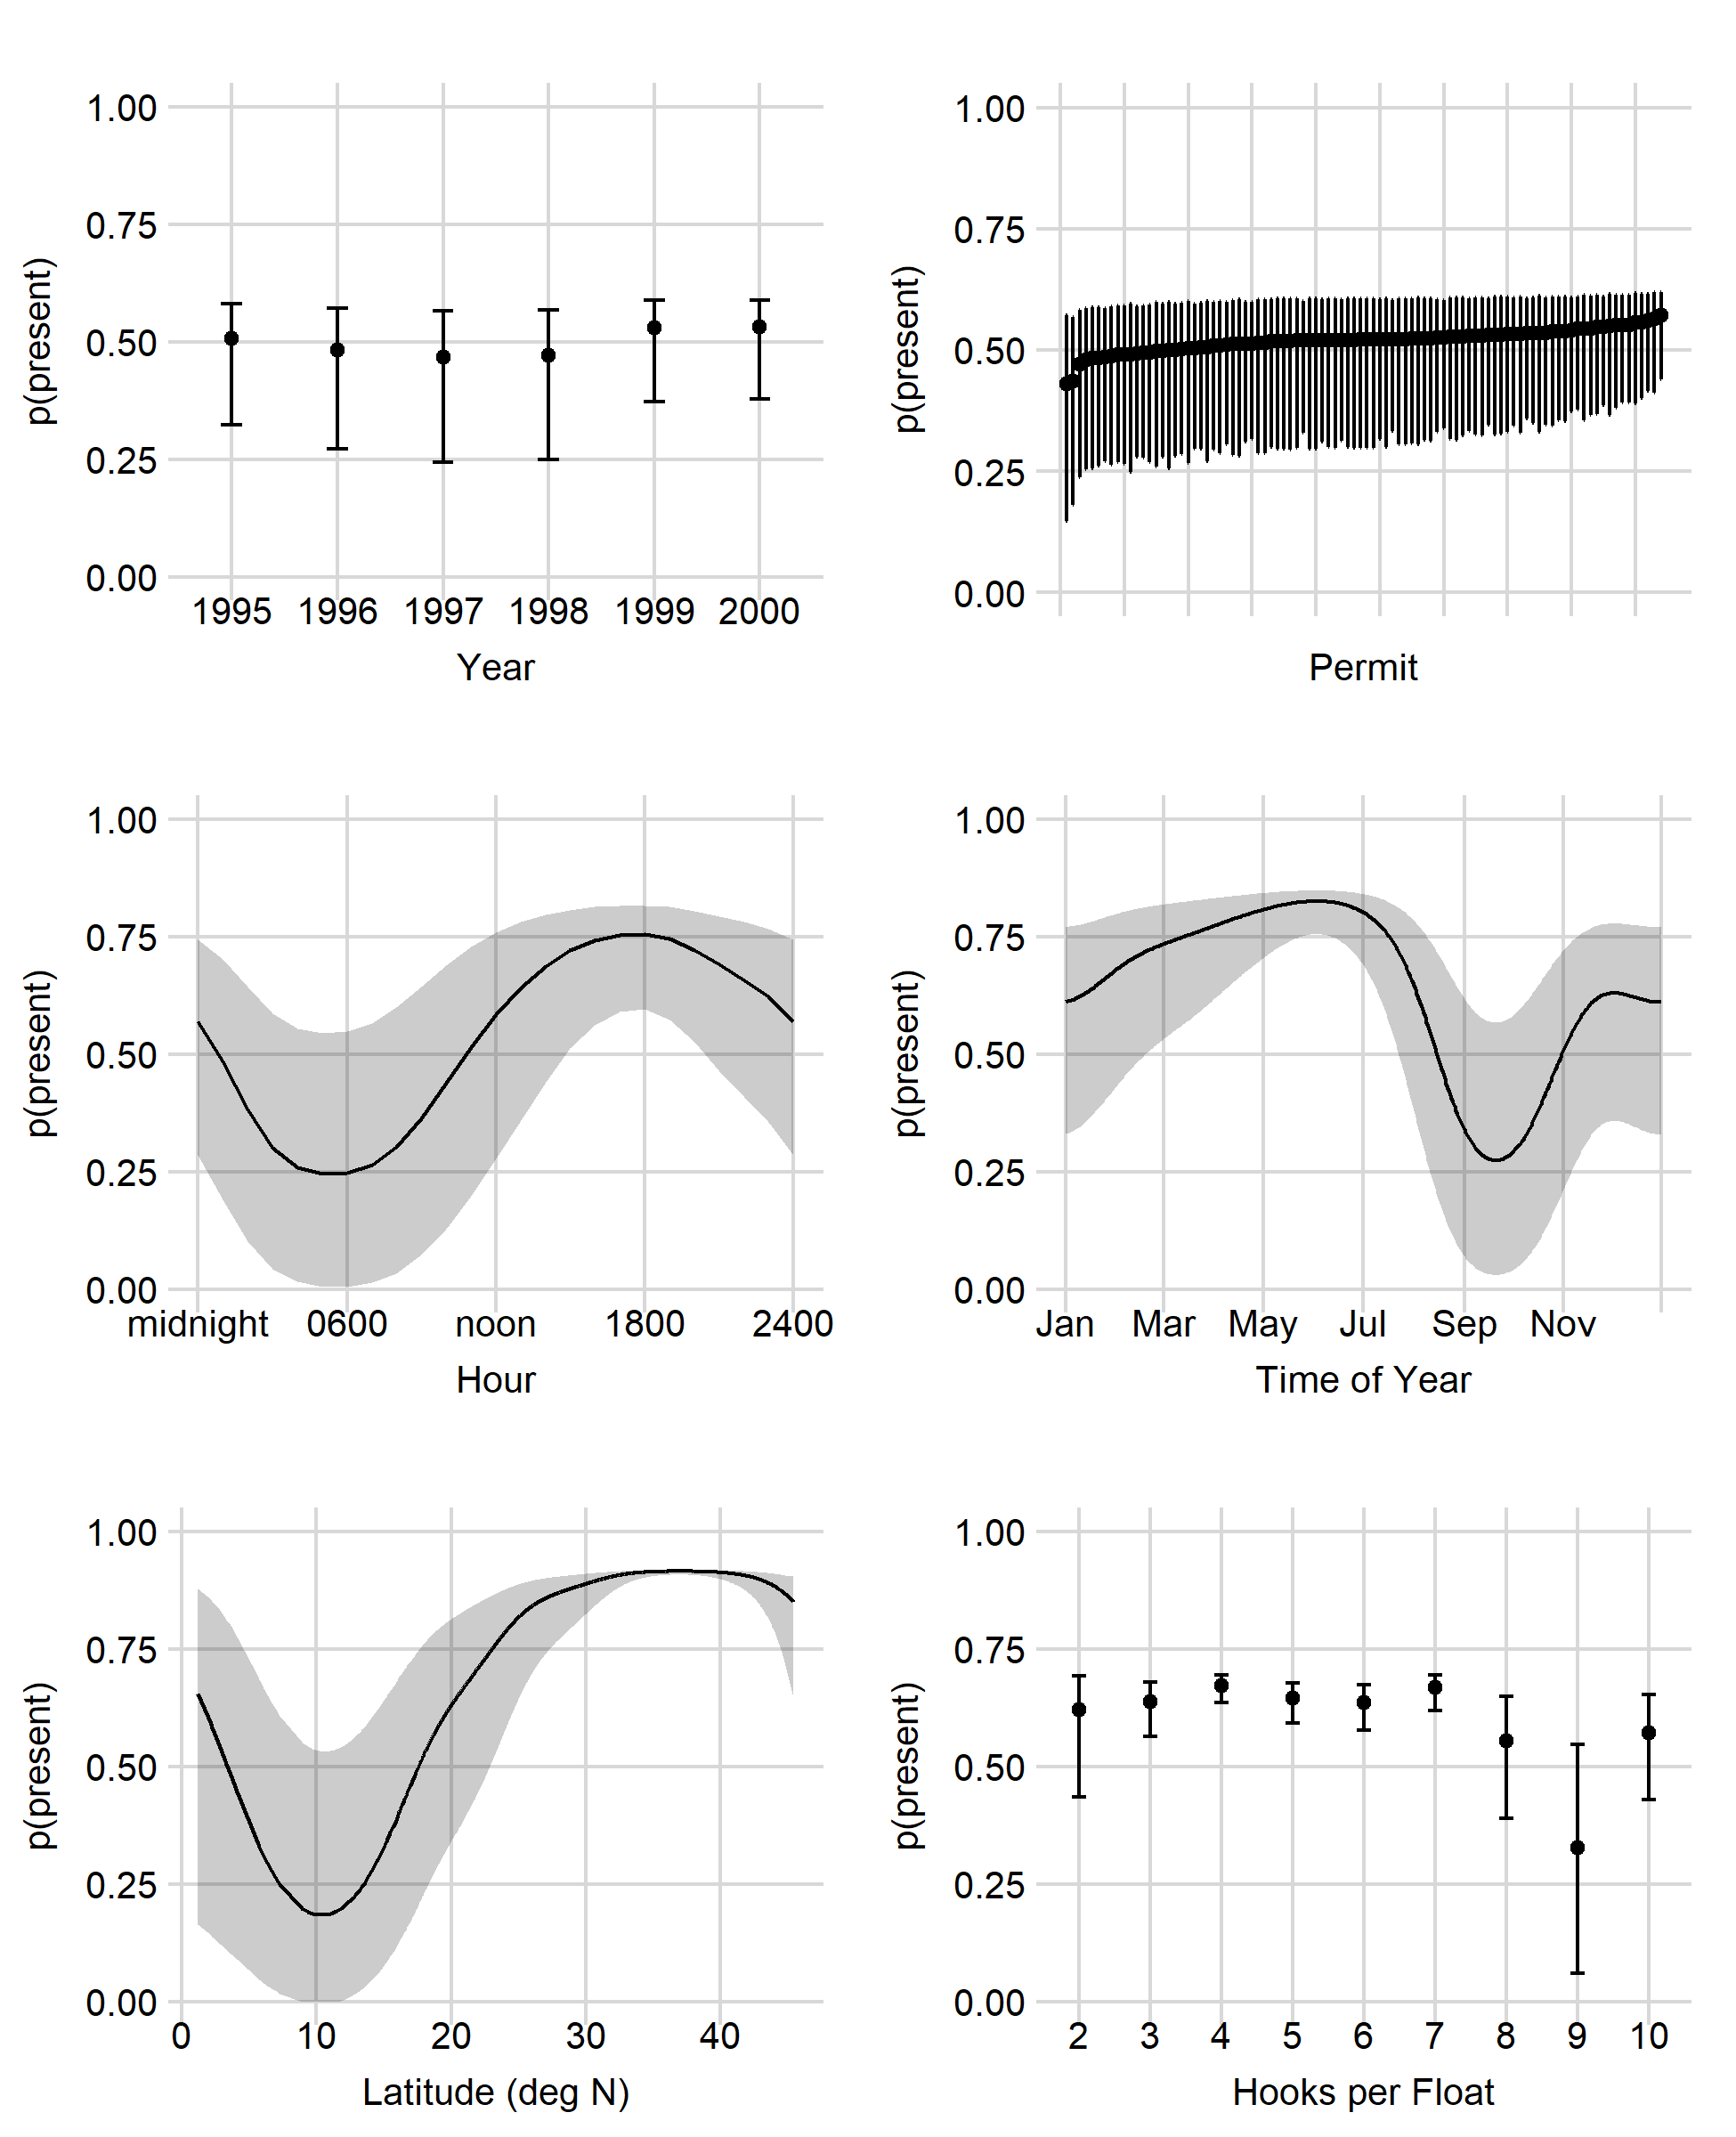

Figure . Shallow set 1995-2000 presence/absence marginal effects.

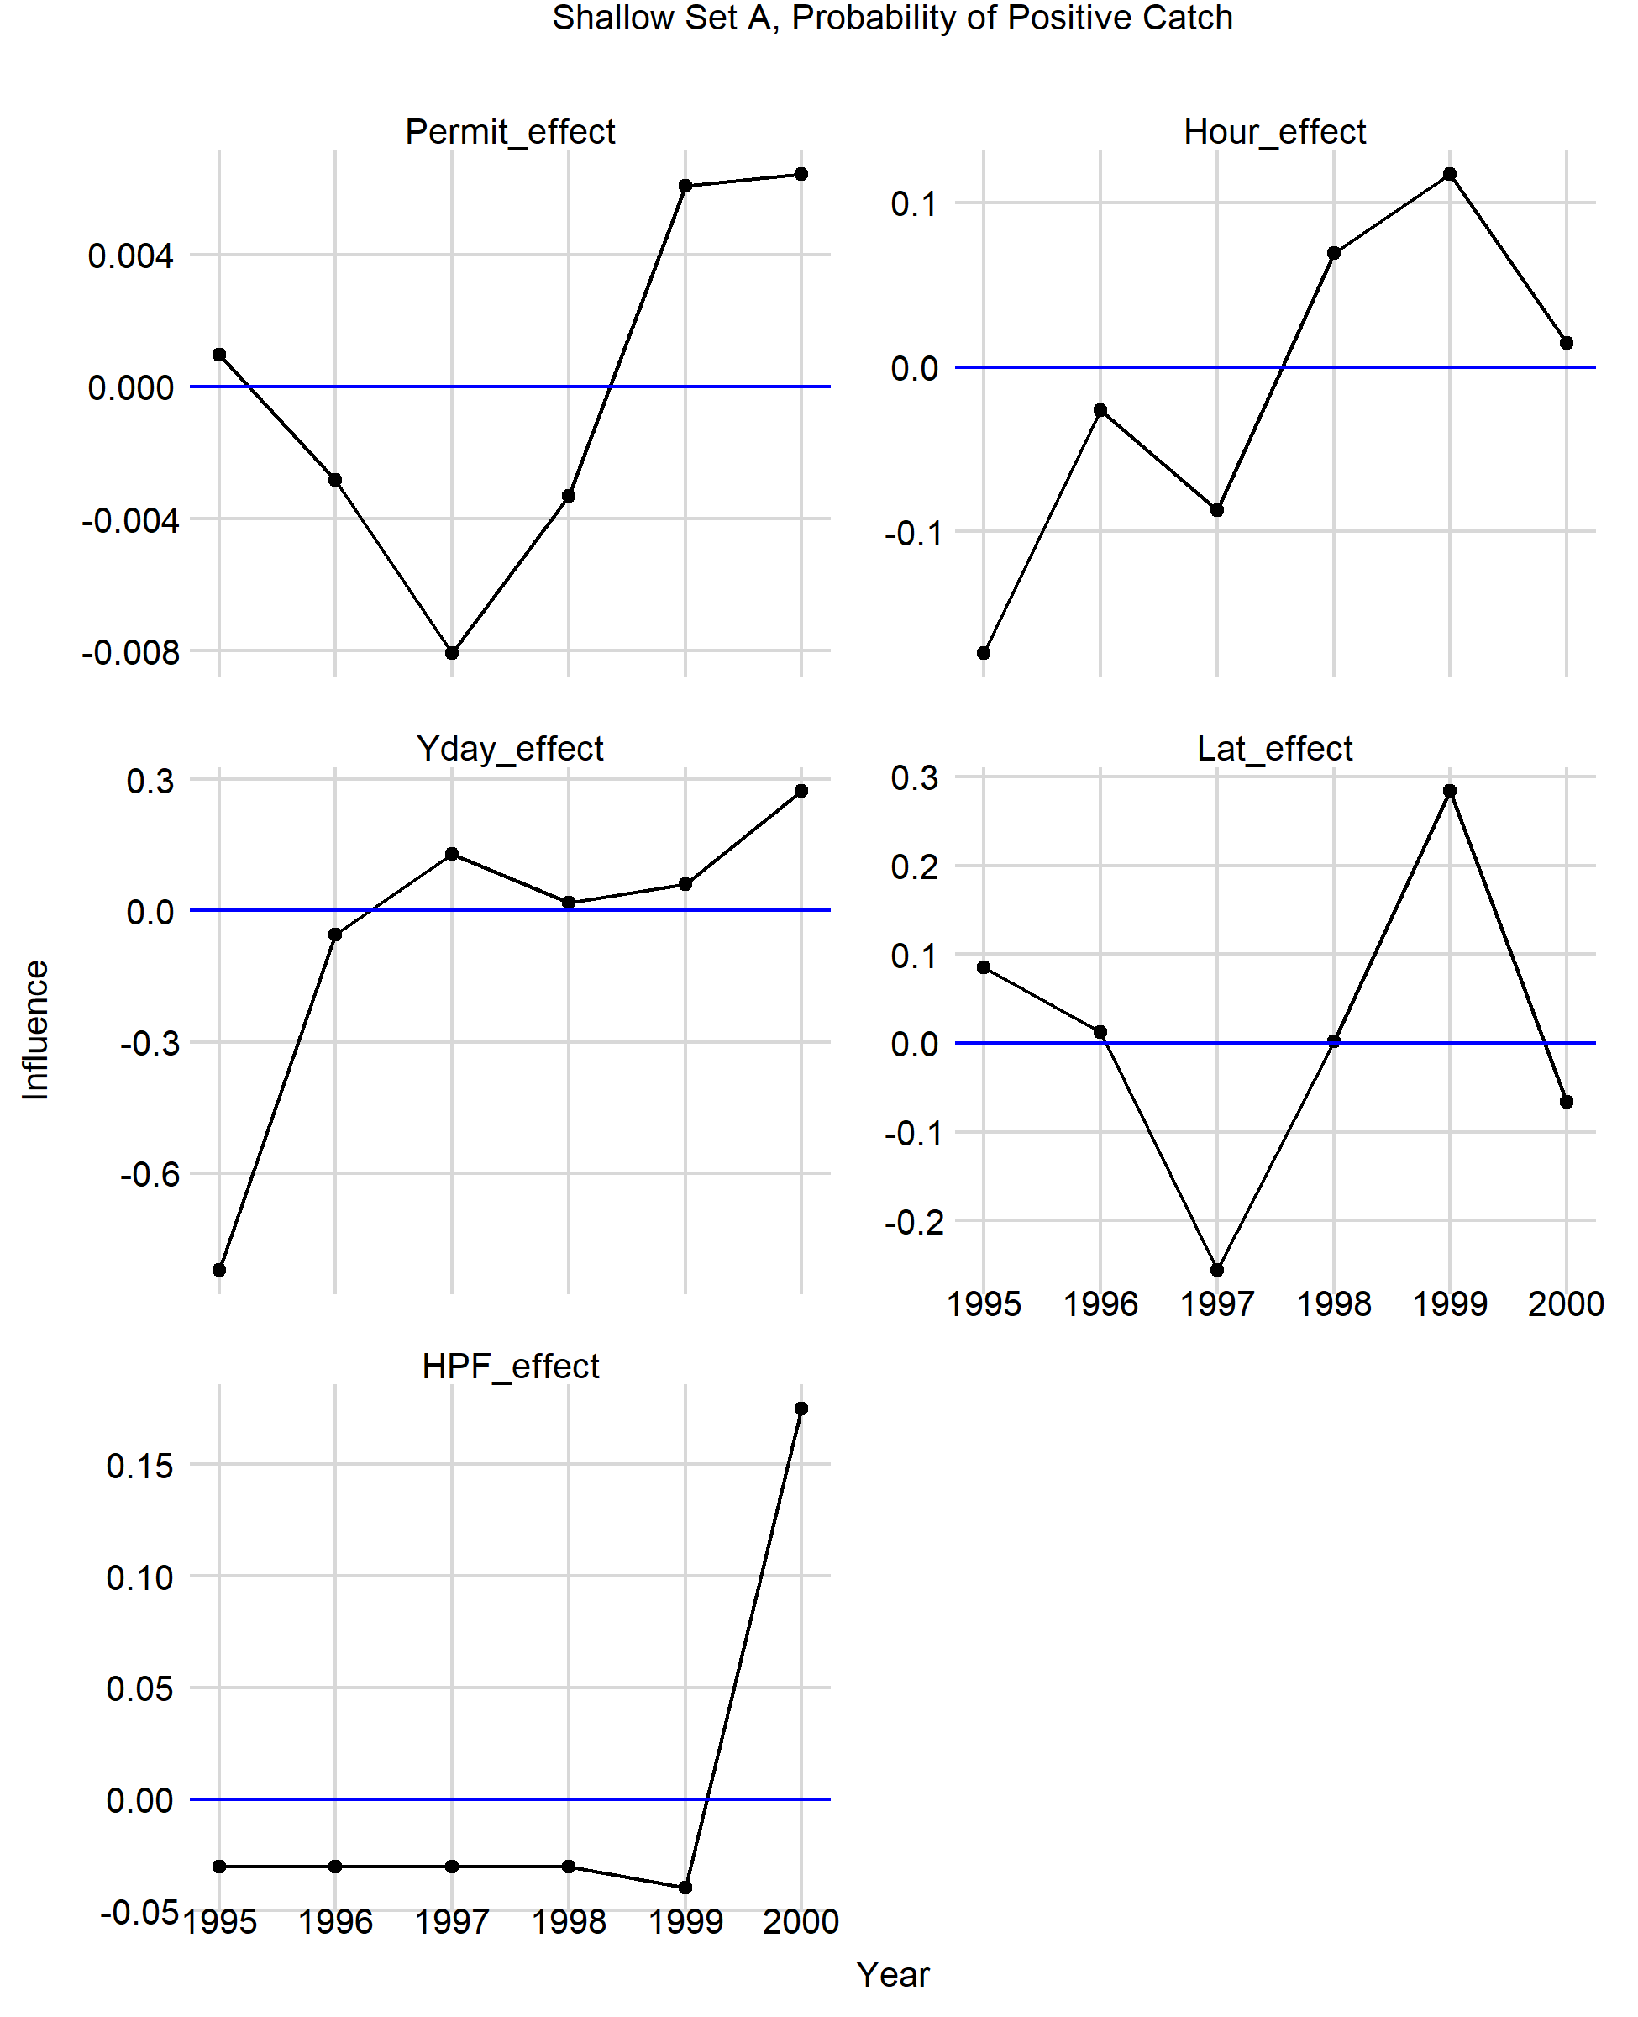

Figure . Influence plots.

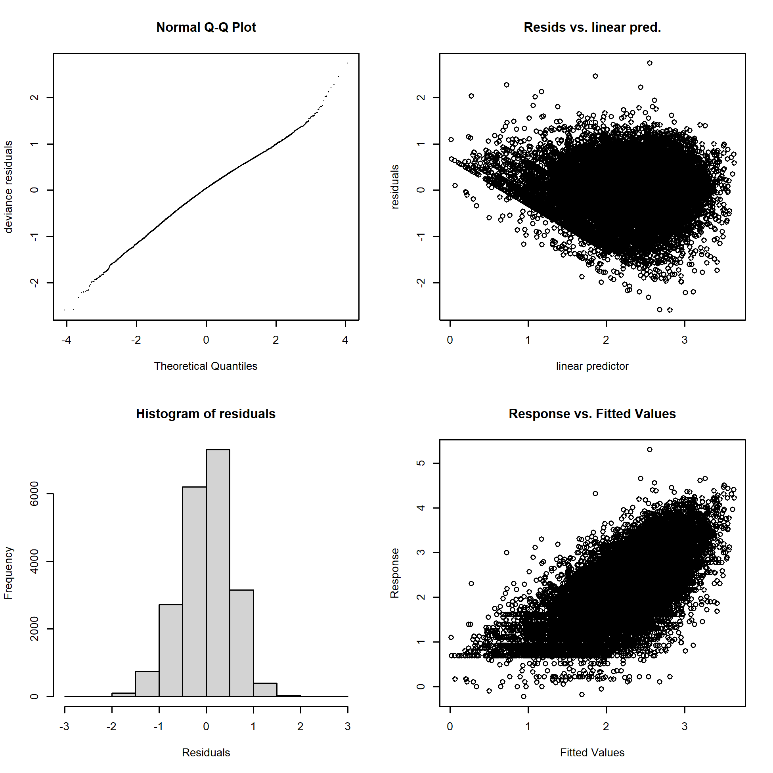

Figure . Shallow set 1995–2000 positive process model diagnostics. Response is shown on the log scale.

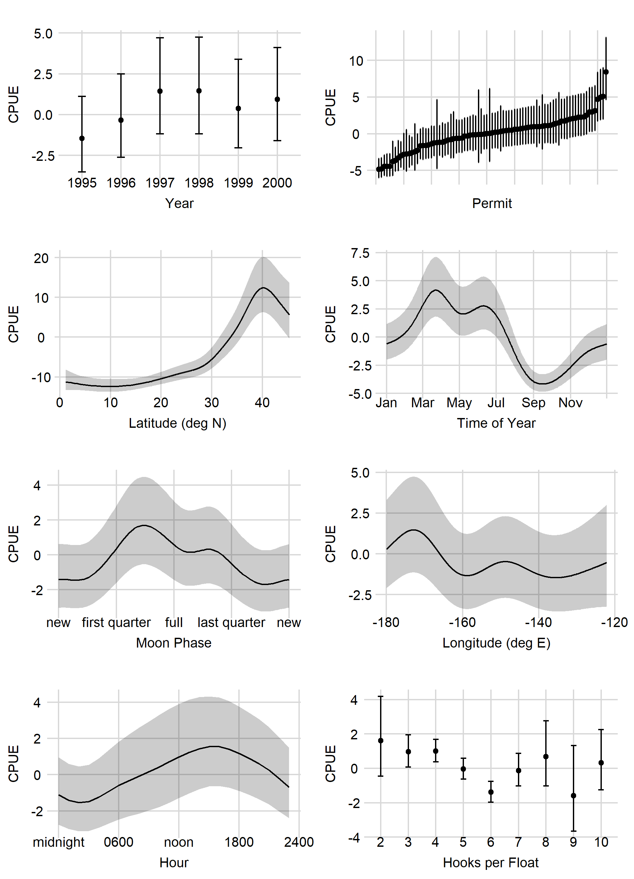

Figure . early LnN marginal effects.

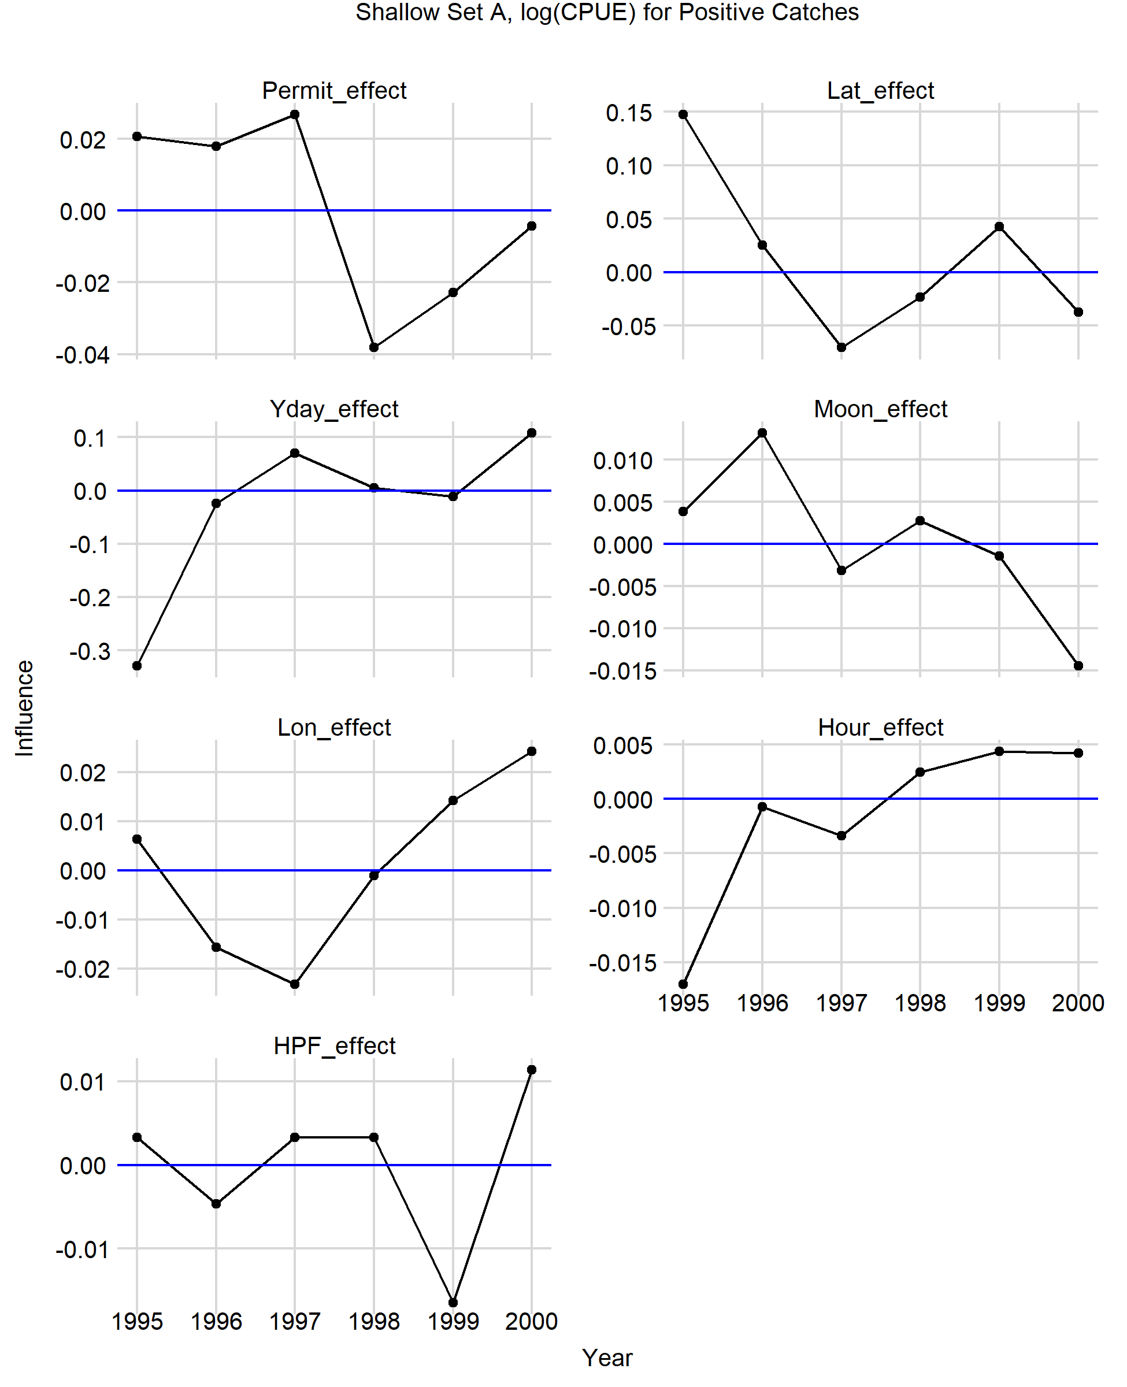

Figure . Early LnN influence.

# 

Figure . Late LnN diagnostics.

# 

Figure . Late LnN marginal effects.

# 

Figure . Late LnN influence.

# 

Figure . Deep set binomial model diagnostics.

# 

Figure . Deepset binomial marginal effects.

# 

Figure . Deep set binomial influence.

# 

Figure . Deep set LnN diagnostics.

# 

Figure . Deepset LnN marginal effects.

# 

Figure . Late LnN influence.

# figs

1. http://www.esrl.noaa.gov/psd/